
Software Development 2013
Outcome 1 Unit 3

Software Requirements Specification
for
Western Institute of Technology

Preface
<With reference to the PSM identify key and sub tasks involved in producing software solution > (4 marks)

Key tasks involved are:
- Allow WIT to manage administrative tasks such as enrollment and grade reporting more efficiently
- Allow for prompt and accurate student details to be entered whilst enrolling student
  - Also, address the issue of students not being recognized as students on their first day
- Allow for more user friendliness and maintainability of the current system
  - Also, allow for an increase in the response rate of the current system
- Investigate potential attempts to sabotage the WIT system
- Allow for a more accurate reporting of student’s progress
- Recommend a more efficient network
- Allow for better access to the system for staff who are on the road
- Recommend better hardware for staff to use
  - Includes but is not limited to:
    - Network hardware
    - Computer hardware
    - Software
    - Computer peripherals

<Propose a range of data collection methods to be utilized during analysis>
<Data collection methods should be descriptive and not be singular words e.g. questionnaire.>
<Justify the appropriateness of the collection methods with reference to it ability to determine needs and requirements> ( 6 marks)

Collection Method | Justification
Interview the current admin staff | - Ask why they think student details take a week to be entered into a student file  - Ask staff their attitude towards the software as well as the hardware  - Ask staff why they think it is that details from mobile enrollment staff can be inaccurate and delayed  - Ask staff what leads them to believe that there are malicious attempts to access the WIT network  - Ask staff why they think mail sent to student’s houses – be it grades or fees – don’t arrive/are sent to the wrong address
Observe the network myself | - Observe any collisions that may occur in the network due to the star topology and network hub  - Identify any flaws in the student enrollment process (user-friendliness, data flow, data store,  - Observe any potential for inaccurate data entry into the system  - Attempt to deduce potential for network intrusion  - Determine security of current network  - Attempt to deduce why response rates of the current network is so abysmal
Research | - Research methods of data entry to forms to make recommendations regarding inaccurate and untimely analogue data movement across current system  - Also, apply researched knowledge to physical mail system mentioned later  - Research current computer components in order to make recommendations on hardware upgrades  - Includes but is not limited to:  - Network hardware  - Computer hardware  - Software  - Computer peripherals  - Research methods by which organizations send physical mail (not email) in order to identify why grades and fees are so often incorrect or are sent to the wrong address  - Research malicious methods by which intruders may gain access to a network such as the WIT system in order to identify any breaches, and if so, to stop it from happening

Introduction

Purpose
<Identify the purpose of the software whose software requirements are specified in this document.> ( 3 marks)
- Who is the target audience?
  - The target audience would ideally be administration staff. The software doesn’t need to be able to do everything a piece of software can do: it simply needs to fulfill the needs of the staff that are using it.
  - Furthermore, the software needs to have a greater emphasis on user response rates, user friendliness, reliability, robustness, and maintainability
- Why do we need new software?
  - The current system simply doesn’t work:
    - It has too much potential for error. In fact, there is an error or something that reduces accuracy and efficiency at nearly every activity
    - It is difficult to use and maintain
- What benefits will the new software bring to the organisation?
  - The new system will:
    - Increase efficiency
    - Decrease any potential for errors
    - Make the business seem more professional. New students having to convince teachers of their identity isn’t something positive

Scope

Items within Scope
<List the software’s capabilities> ( 5 marks )

The items that are within scope of this project include:
- Produce a software solution that will allow for more efficient administrative activities such as:
  - Enrollment
  - Grade reporting
  - Billing
- These changes will be implemented for those in the office and on the road
- The new software/system will allow for an increase in the response rate, user friendliness, robustness, and maintainability of the current system
- Investigate and attempt to address any issues pertaining to system security
- Recommend better hardware for staff to use

Items not in Scope
<List the capabilities the software will not include> ( 2 marks)

Items not in the scope of the solution are:
- Provide unrealistic response times, usability factors, and maintainability
- Guarantee that any analogue to digital conversion of data will be 100% accurate
- Staff will be able to use all new hardware – we’re not here to educate
- Insurance of complete network security from malicious attack
- That the solution will work forever, in terms of timeliness
- Guarantee that physical mail will be sent to the correct address – we can only guarantee that the correct address will be placed on the letter, from there it is the post company

Operating Environment
<Describe the networked environment (physical layer) in which the software will operate (including type of network, hardware, software (operating system and application) and protocols.> ( 7 marks )

The physical layer of the OSI describes the method by which data is transmitted via physical means. The current network is in a ‘star’ topology; however I recommend changing it into a star/P2P hybrid whereby all computers can connect to the FTP server as well as the switch. This means that all of the computers, printers, router(s), and the file server connect to a single switch, while also having an Ethernet connection to the file server. In terms of protocols, it firstly uses TCP to split any packets up into smaller ones therefore making it easier for transport. Then, IP takes control and decides where those packets should go and which method it should take to get there. POP3, IMAP, SMAP are email protocols and operate on the Application Layer of the OSI. HTTP is the protocol that will be used second most after TCP/IP and it essentially there for transferring web pages. UDP won’t be used much in a work context as it is there for streaming mostly. Ethernet is the protocol that governs how computers hardwired into a node interact; as this star/P2P network interconnects largely, perhaps one of the most used protocols would be Ethernet. In conjunction with Ethernet, the WiFi protocol would be used to allow laptops to connect to a router which is connected to the central switch.

As for the software end of things,

<Discuss the network functionality and security vulnerabilities. You should address the vulnerabilities identified> ( 8 marks)

As with virtually any network, there is always potential for vulnerabilities. Firstly, if WIT don’t have a decent firewall, then there can be an intrusion. What a firewall does is provide for a means to block out any ‘ports’ whereby malicious packets are able to come into the network and access a node.

<Discuss recommendations you would make to improve the networking at WIT. Justify your recommendations in terms of improvements to efficiency and effectiveness.> ( 7 marks)

Firstly, I’d abolish the use of a hub in a star topology – it is outdated and prone to inefficiencies. I’d recommend buying a switch with AT LEAST 100Mbit/s throughput as the current bandwidth of 10Mbit/s is not enough for 6 PC’s, 6 netbooks, 2 printers, and an FTP server. Buying a switch will allow for less ‘collisions’ on the network whereby multiple packets of data are sent down a common line and cause a complete disruption for that line, Ethernet protocol dictates that a random amount of time must be spent before resending that packet of data therefore addressing this issue will amend massive inefficiencies that occur to simple hardware faults. As for the computer’s NICs, I see no reason to change them as they support 100Mbit/s functionality therefore there won’t be any bottlenecking.

Furthermore, I’d recommend rearranging the network layout to a star/P2P hybrid. The new network design will have the existing file server connected to every computer. By doing so, you will be able to save money by buying a cheaper switch as it doesn’t have to handle as much data anymore. Existing PC’s will still be connected to a central switch (should you chose to implement my recommendations) and the wireless laptops can connect to a router, which will connect to the aforementioned switch.

The type of Ethernet cables currently used is Cat3 cables. I’d recommend switching to Cat5 UTP cables to allow for less electromagnetic interference, therefore allowing for more cables to be tucked into tighter places without signal drop.

Functional Requirements

Functional Requirements
<Itemize the detailed functional requirements. Include how the product should respond to anticipated error conditions or invalid inputs. Requirements should be concise, complete, unambiguous, verifiable, and necessary. Each requirement should be uniquely identified with a sequence number.> ( 5 marks)
<Add additional rows until all functional requirements are listed>
No | Requirement | Notes
FR01 | Create student file | The new system will allow for more user input, and will be able to complete a student file with accuracy therefore the output will be greatly improved too. All entry fields are checked for relevancy (e.g. can’t enter strings into student number)
FR02 | Better cater for mobile staff | The new system will allow mobile staff to directly input anything they need to directly to admin. This will eliminate an awkward process that allows for “mistakes and delays to happen at this stage” and therefore is its own verifying stage, as it skips the stage that was causing inaccuracies and inefficiencies
FR03 | Better cater for teachers | Any student information will be directly accessible from the appropriate teacher’s laptop, this eliminates the students having difficulty in proving that they’re enrolled. The input in this case is the teacher’s request to see student details (in order to verify enrollment) in case the student loses their ID card and advice details or if they’re a new student. The system will only allow for teachers to see only their student’s files (ex. Phone numbers, addresses, etc.)
FR04 | Better mail home | The new system will allow for admin to not only send the right details home, but also to the right home too. It cross-checks for any bad input on the end of the admin receptionists and verifies that the right files go to the right places.
FR05

Context Diagram
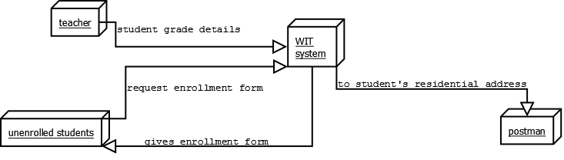
Draw a context diagram of the existing enrollment system at WIT and paste a jpg of the diagram here.( 4 marks)

Data Flow Diagram
After Identifying each of the following, draw and insert a data flow diagram of the existing enrollment information system.

Entities
Admin, students, postman, mobile enrollment staff, teachers,
Processes
Calculate enrollment fees, print mobile enrollments, calculate enrollment fees, mail enrollment advice/invoices, payment, print student receipt
Data flows
Student submits information with course selection details, payment details put on student file, send class list to respective teacher, teacher sends admin student grades,
Data store
Student file, class list,

Insert a Data Flow Diagram as a jpg ( 8 marks)
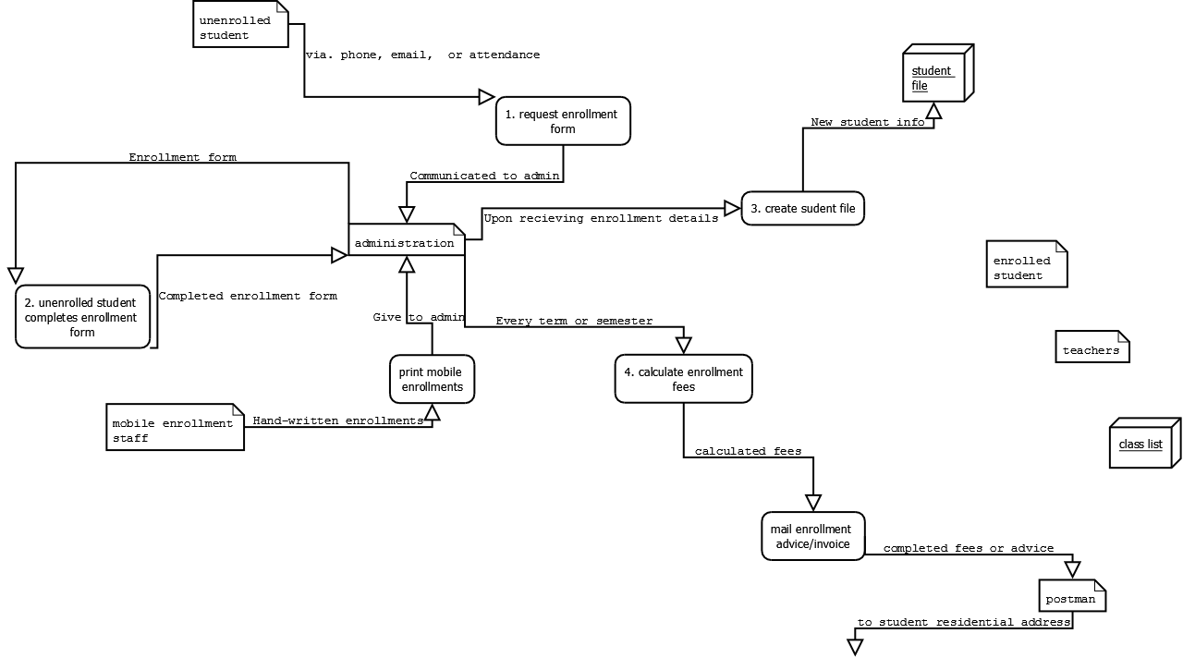

Use Case
<Itemize each Use Case>
<Add additional rows until all use cases are listed>

No | Use Case | Notes
UC01
UC02

Use Case Diagrams
Insert a Use Case Diagram as a jpg ( 8 marks )

Non-Functional Requirements
<Itemize the non-functional requirements such as user-friendliness, response rates, robustness, portability, reliability and maintainability. Write these to be specific, quantitative, and verifiable when possible. Each requirement should be uniquely identified with a sequence number. You must explain and justify each non-functional requirement. > ( 10 marks)

<Add additional rows until all non functional requirements are listed>

No | Requirement | Notes
NFR01 | Response rates | The current system is outdated and its low response rates are why WIT looked for IT assistance in the first place. It should be able to perform tasks 200% faster than the old system and achieve 100% accuracy.
NFR02 | User friendliness | Because WIT doesn’t have tech staff, the program has to be extremely user friendly. It should be able to be adapted by staff within a month and the staff should be able to complete all functions of the program within a month.

Constraints
<Describe any items or issues that will limit the options available to the developers. > ( 5 marks)

Factors that may limit the developers are:
- Time
  - There is a set amount of time for any job. Obviously, the more time you put in, the better the final product would be. However, the developers need to complete what’s the scope within the allocated time frame
- Cost
  - This isn’t a hugely massive business. They’re not going to have the money (or even the need) to buy ridiculous hardware or overpriced software. The cost limits just what we can recommend WIT to buy and use. Furthermore, in the long run, powerful computer hardware (or a lot of computer hardware) will drive electricity prices.
- User knowledge
  - The UI will have to be simple enough for those of us who aren’t tech savvy can use it. The UI shouldn’t differ too much from the previous system in order to make transition easier.
- Security
  - Users currently report possibilities that the system is infiltrated, that indicates that there is potential for an attack. The new system will have to be able to withstand an attack and also be robust if the attackers get in.
- Availability of tech staff
  - Currently, there isn’t any tech support at WIT. This means that the developers will have to make the software extremely robust or they should provide a detailed help file should something go wrong

